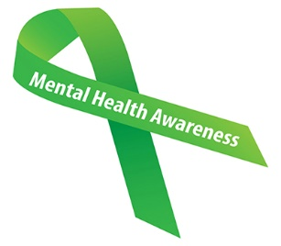

ARE YOU AGED 25 OR UNDER? FEELING ANXIOUS, UPSET OR NEED SUPPORT?

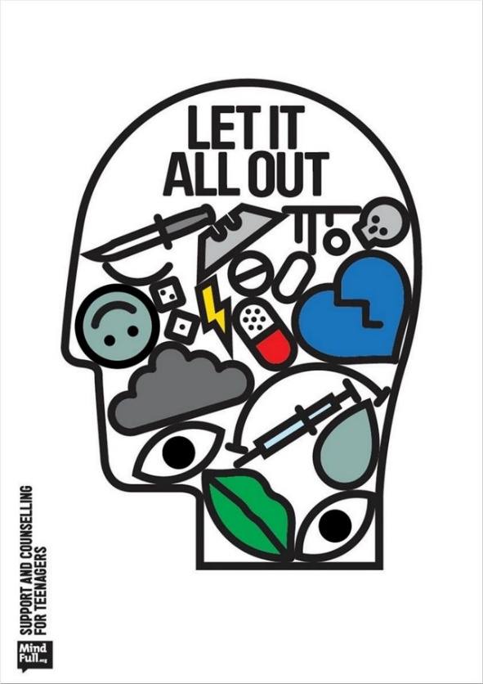

*Pick up this flyer to find out more about services available for young adults*

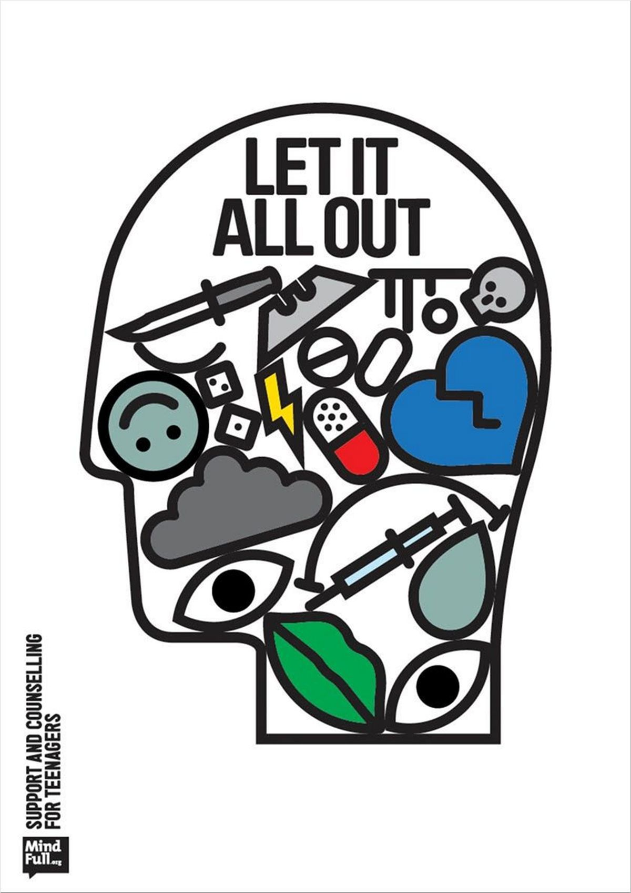

Your GP is here to help or you can speak to any member of the team

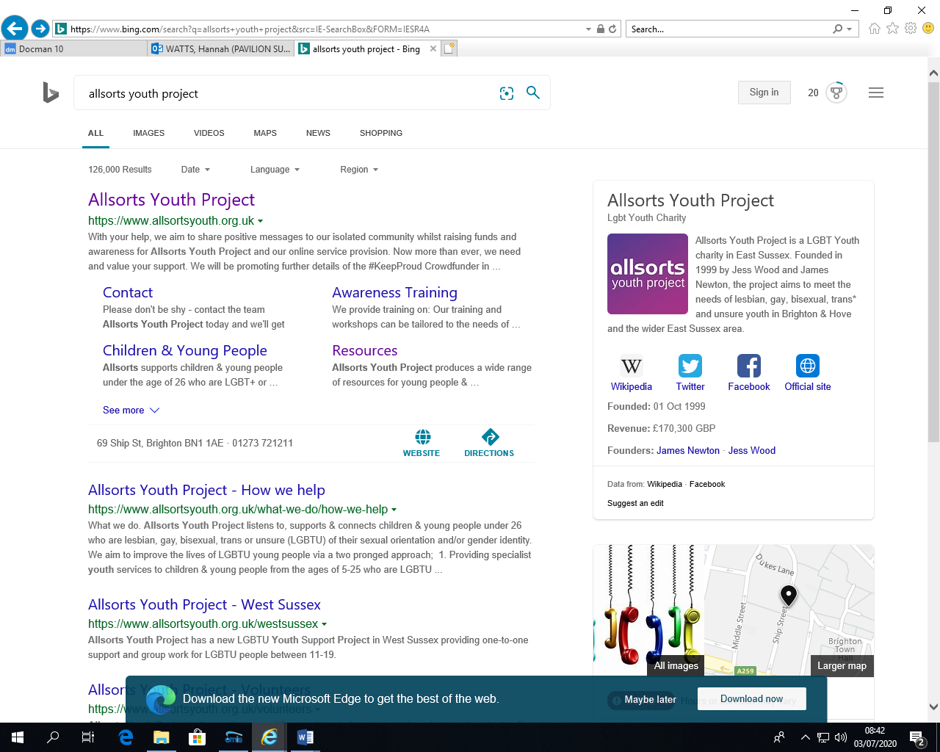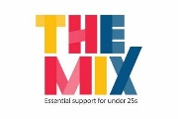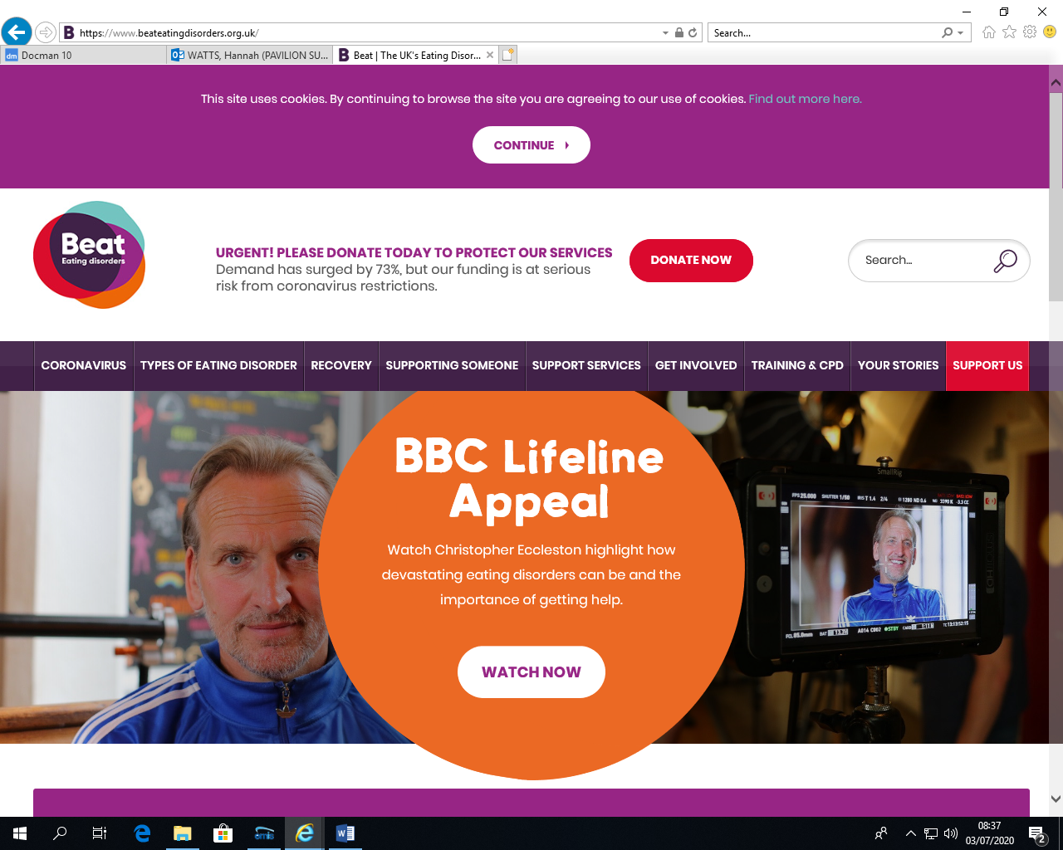

**YMCA Mediation Service:**

If there are arguments at home, we can help. The YMCA offers a safe space for 14 to 25 year olds to talk, mediate, listen and help you work things out.

**Telephone: 01273 624432**

**Email:** [**YAC.familymediation@ymcadlg.org**](mailto:YAC.familymediation@ymcadlg.org)

<https://www.ymcadlg.org/what-we-do/support-and-advice/youth-advice-centre-yac/>

**THE MIX;**

The UK’s leading support service for young people. We are here to help you take on any challenge you’re facing- from mental health to money, from homelessness to finding a job, from break-ups to drugs.

Telephone: 0808 808 4994

Crisis Messenger: [www.themix.org.uk](http://www.themix.org.uk)

**BEAT:**

We’re here for you if you or someone you love is suffering from an eating disorder or symptoms. We help support people with eating disorders on their journey to recovery.

**Helpline: 0808 801 0677 Student Line: 0808 801 0811**

**Youth Line: 0808 801 0711**

<https://www.beateatingdisorders.org.uk/>

**ALLSORTS Youth Project:**

Allsorts is a project based in Brighton to support and empower young people under 26 who are lesbian, gay, bisexual, trans or unsure (LGBTU) of their sexual orientation and/or gender identity.

**Telephone: 01273 721 211**

<https://www.allsortsyouth.org.uk/>

**TAPA:**

A mental Health service for young people aged 14-25, offering advice and support to young people experiencing mental/emotion health problems or related issues.

**Telephone: 01273 718680**

<http://www.socialsubcultural.com/ruok/?page_id=334>